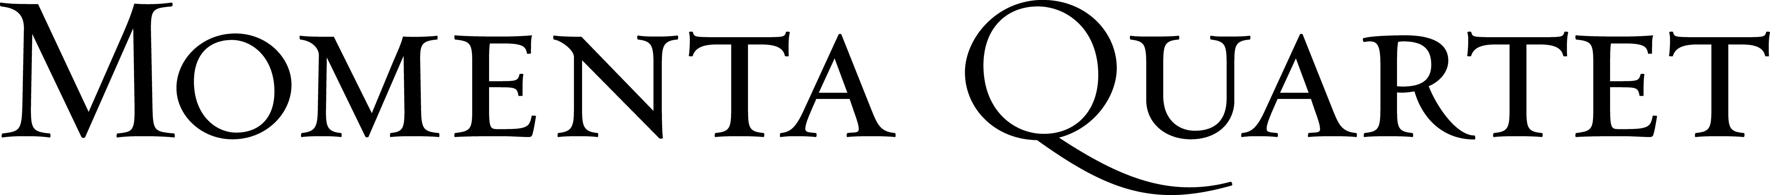

Press Quotes

“Word of the Momenta Quartet’s diligence, curiosity and excellence is definitely out.”
-Steve Smith, The New York Times

“The Momentas were at their most potent in Haydn’s Quartet Opus 20 No. 1, applying opulent, sustained legato in the slow movement. Few American players assume Haydn’s idioms with such ease.”
-Alex Ross, The New Yorker

“[They] unleashed a veritable firestorm of intensity… Momenta inhabited every note in an impassioned reading that combined brilliant virtuosity with the utmost sympathy and unity of intent.”
-Patrick Rucker, The Washington Post

“The performance was taut and compelling.”
-James R. Oestreich, The New York Times

“An outstanding young string quartet with an exceptionally broad range.”
-Russell Platt, The New Yorker

“The Momenta Quartet gave it a warm, graceful reading... a focused, fluid performance.”
-Allan Kozinn, The New York Times

“The Momenta players unleashed an utterly abstract, utterly beautiful sonic skyscape... an extraordinary musical experience.”
-Stephen Brookes, The Washington Post

“The Momenta players brought delicacy and understated confidence... with a burnished tone and judicious vibrato.”
-Strad Magazine

“Razor-sharp musical focus”
-Christian Carey, Musical America

“A relentless, edge-of-the-seat performance.”
“Momenta brought an emotional commitment… that was almost unbearably intense, in a delicious way.”
-John Fleming, Classical Voice North America

“A paragon of the concert-going experience: excellent music that was entirely fresh and new, played with skill and élan… Momenta’s playing throughout the concert was superb.”
- George Grella, New York Classical Review

“An outstanding ensemble prone to innovation and exploration.”
-Time Out New York

For more information, including audio and video: www.MomentaQuartet.com

Stay connected through Facebook and Twitter: www.facebook.com/MomentaQuartet www.twitter.com/MomentaQT

